The Tamron SP 24-70mm F/2.8 Di VC USD (Model A007) was announced in February 2012, just one day before the Canon EF 24-70mm f/2.8L II USM. Its headline feature is indicated by the 'VC' in its name, which stands for 'Vibration Control'; it's the first and only optically-stabilized fast normal zoom for full frame cameras. As befits a premium SLR lens it also includes an ultrasonic-type autofocus motor for fast and silent focusing, and as an added bonus it features a degree of weathersealing (Tamron uses the term 'drip proof'). Put together, this makes it the highest-specified 24-70mm lens currently on the market.
To achieve this feat, Tamron has employed an exotic optical formula that makes extensive use of special elements. It includes three Low Dispersion (LD) glass elements, two Extra Refractive Index (XR) glass elements, three glass molded aspheric elements, and one hybrid aspherical element in its 17 element / 12 group design. A 9-bladed aperture diaphragm uses curved blades for the attractive rendition of out-of-focus backgrounds.
As usual for Tamron the lens is available in versions for Canon, Nikon and Sony SLRs. The latter doesn't include optical stabilization, relying instead on the camera body's built-in sensor-shift stabilization, and drops the 'VC' from its name as a result. But in all other respects it's identical, including the same optical design.
What's perhaps most impressive about the 24-70mm F2.8 VC, though, is its price. At around $1300/£800 it's significantly cheaper than Canon, Nikon and Sony's own 24-70mm F2.8 lenses, although it's rather more expensive than Sigma's older, unstabilized model. You could be forgiven for thinking this is too good to be true - on paper it looks like a steal. So the question is: how well does it work in practical use? Read on to find out.

Headline features
- 24-70mm focal length
- Fast F2.8 constant maximum aperture; F22 minimum
- Vibration Control (VC) optical image stabilization
- Ring-type Ultrasonic Drive (USD) focusing with full-time manual override
- 0.38m closest focus, offering 0.2x magnification
- For Canon, Nikon and Sony mounts (Sony version doesn't have VC)

Angle of view
The pictures below illustrate the angle of view on Canon full frame and APS-C cameras (taken from our standard position):
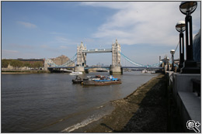
24mm, full frame | 70mm, full frame
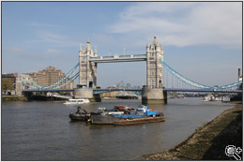 | 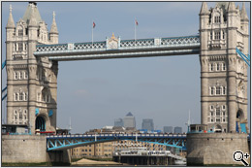
24mm, 1.6x APS-C (38mm equivalent) | 70mm, 1.6x APS-C (112mm equivalent)

Tamron SP 24-70mm F/2.8 Di VC USD specifications
Price | • $1300 (US)  • £810 (UK)
Date introduced | February 2012
Maximum format size | 35mm full frame
Focal length | 24-70mm
35mm equivalent focal length (APS-C) | 38-112mm
Diagonal Angle of view | • 84-34º (full frame)  • 61-23º (1.5x APS-C)
Maximum aperture | F2.8
Minimum aperture | F22
Lens Construction | • 17 elements / 12 groups  • 3 LD (Low Dispersion) elements  • 2 XR (Extra Refractive Index) elements  • 3 glass molded aspheric elements  • 1 hybrid aspherical element
Number of diaphragm blades | 9, rounded
Minimum focus | 0.38m
Maximum magnification | 0.2x
AF motor type | • Ring-type Ultrasonic Drive motor  • Full-time manual focus
Zoom method | Rotary, extending
Focus method | Internal
Image stabilization | • Yes (not available on Sony mount version)
Filter thread | • 82mm  • Does not rotate on focus
Supplied accessories* | • Front and rear caps  • Petal-type Hood HA007  • Soft lens case
Weight | 845 g (29.1 oz)
Dimensions | 88.2 mm diameter x 116.9 mm length  (3.5 x 4.6 in)
Available Mounts | Canon EF, Nikon F, Sony Alpha

